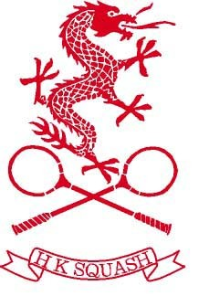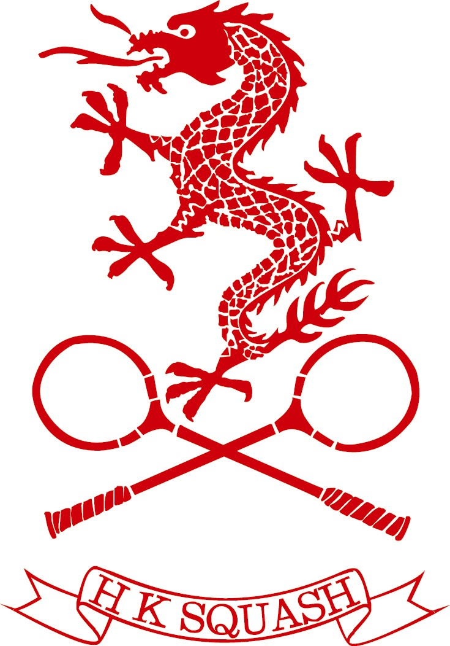
Cathay Pacific Sun Hung Kai Financial Hong Kong Squash Open 2013

1 – 8 December 2013

Ticket Booking Form

To: Hong Kong Squash Fax No: (852) 2869 0118 Attn: Ms Cady Yu

Email: cady@hksquash.org.hk website: www.hksquashopen.com Tel: (852) 2523 2225

******************************************************************************************************************************
Name: |  | Email:

Contact No. |  | Fax No.

HK Squash/The Marco Polo Club/ SHKF membership/account no.
Reserved ticket(s):
1 Dec (Sun)  1:00pm – finish  HKSC | Qualifying  1st Round | Free entry | Free entry | Free entry | Free entry
2 Dec (Mon)  1:30pm – finish HKSC | Qualifying  2nd Round | Free entry | Free entry | Free entry | Free entry
3 Dec (Tue)  1:30pm - finish HKSC | Main Draw  1st Round | $60 (Public)  $50 (Members) | Free seating | Quantity | HK$
4 Dec (Wed)  1:30pm - finish  HKSC | Main Draw  1st Round | $60 (Public)  $50 (Members) | Free seating | Quantity | HK$
5 Dec (Thur)  1:30pm - finish  HKSC | Main Draw  2nd Round | $100 (Public)  $80 (Members) | Free seating | Quantity | HK$
6 Dec (Fri)  2:00pm – finish HKSC | Quarter Finals | $150 (Public)  $120 (Members) | Free seating | Quantity | HK$
7 Dec (Sat)  6:00pm – finish  venue: HKCC | Semi Finals  General Seats | $180 (Public)  $150 (Members) | Free seating | Quantity | HK$
7 Dec (Sat)  6:00pm – finish  venue: HKCC | Semi Finals  Prime Seats | $300 (Public)  $250 (Members) | Row No.  Seat No. | Quantity  SOLD OUT | HK$
8 Dec (Sun)  6:00pm – finish  venue: HKCC | Finals  General Seats | $220 (Public)  $180 (Members) | Free seating | Quantity  SOLD OUT | HK$
8 Dec (Sun)  6:00pm – finish  venue: HKCC | Finals  Prime Seats | $350 (Public)  $280 (Members) | Row No.  Seat No. | Quantity  SOLD OUT | HK$
 |  |  |  | Total HK$
Payment Methods:
E-transfer /ATM - Name of Bank & Account No.: HSBC 002 - 222511 - 003 Name of beneficiary “HONG KONG SQUASH”. E-mail payment receipt to cady@hksquash.org.hk or fax to (852) 2869 0118 for verification.
Notice:
Office hour for the Ticketing office at HK Squash Office during the HK Squash Open
30 Nov 2013 (Sat) – 1pm – 5pm
1 Dec 2013 (Sun) – 12:30pm – 6pm
2 – 6 Dec 2013 (Mon – Fri) 10am – until the last match
*** (HKSC) HK Squash Centre, 23 Cotton Tree Drive, Hong Kong
*** (HKCC) Piazza, Hong Kong Cultural Centre, 10 Salisbury Road, Tsim Sha Tsui, Kowloon
*** (M) HK Squash members/The Marco Polo Club members/SHKF members can only purchase maximum 4 discounted tickets each day.
*** Please collect your reserved tickets within 1 week after confirmed by Hong Kong Squash, otherwise tickets will be released.
*** Members should present membership card when collecting tickets.

